

EVENT PLANNING FOR PUBLIC RELATIONS
December 2021

Meghan Hartwig
Edilia Frederique
Ilene de Vera
Maria Valladares

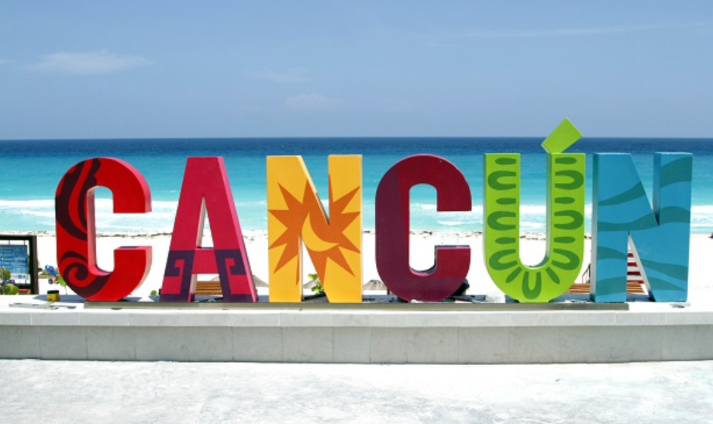

WELCOME TO CANCUN, MEXICO

This year, we are proposing to host our Incentive Conference in Cancun, Mexico. This destination is a top 5 favorite for Canadian travelers, and we all know why: white sand beaches, five-star all-inclusive resorts, fantastic food, and outstanding customer service. However, this proposal has much more to offer. Let's discover this paradise together.

*Please note that Xcaret Arte Hotel provided all the costs-related information. Images and other relevant details were found on the hotel's webpage.

XCARET ARTE HOTEL

Xcaret Arte Hotel opened its doors in July 2021; it represents the ultimate expression of contemporary art in a privileged area facing the Caribbean Sea. Its eco-integrating architecture blends design and nature lovingly and responsibly, achieving a balance between ethics and aesthetics. The whole concept embraces respect and care for the Mayan Region.
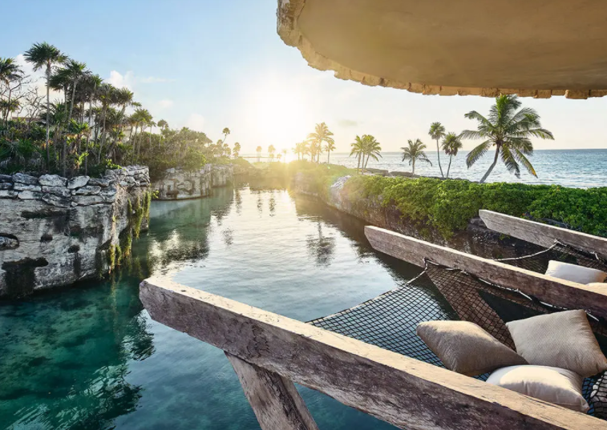

Xcaret Arte is a living homage to the best Mexican artist. It has 900 adults-only suites, all of them inspired by Mexican folklore, colors, fabrics, and masterpieces. The suites are distributed in buildings called Houses: the Artists House, the Design House, the Music House, the Pyramid House, and Peace House. Each house has its own front desk; this is extremely helpful at the arrival, as guests will not experience long lines. The hotel also offers a high-speed internet connection, event consultation/supervision, superior sound system, and videoconferencing.
  - All-fun-inclusive

The guests will enjoy a gastronomic experience at Xcaret Arte; the hotel counts with nine different restaurants. The chefs can prepare all types of delicacies, and each restaurant has its own atmosphere. Also, all restaurants include vegetarian and vegan options.
In addition, the team will have unlimited access to Xcaret, Xel-Há, Xplor, Xplor Fuego, Xenses, Xoximilco, Xavage, and Xenotes.
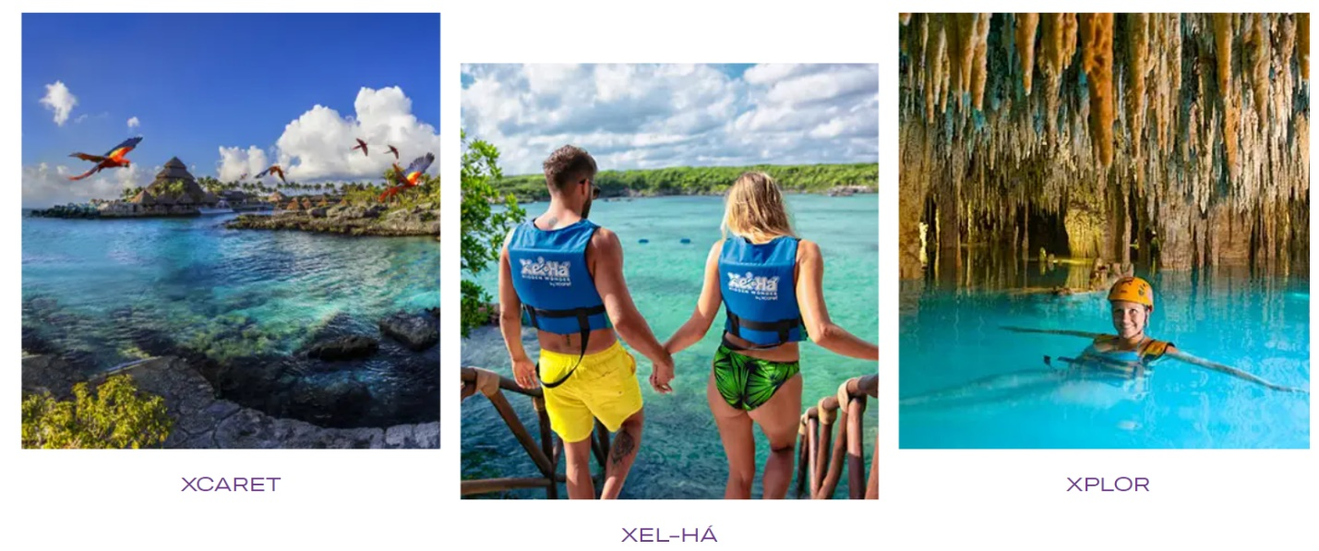

  - Location and Transportation

Xcaret Arte is located in the heart of the Mayan Riviera in front of the Caribbean Sea. As a free-of-charge service, the hotel offers round transportation to the airport every 30 minutes. The buses have a 45 seated passengers capacity, and each person is allowed to carry one bag of 23 kilos. In addition, the hotel offers free round transportation to the themed parks every 30 minutes.

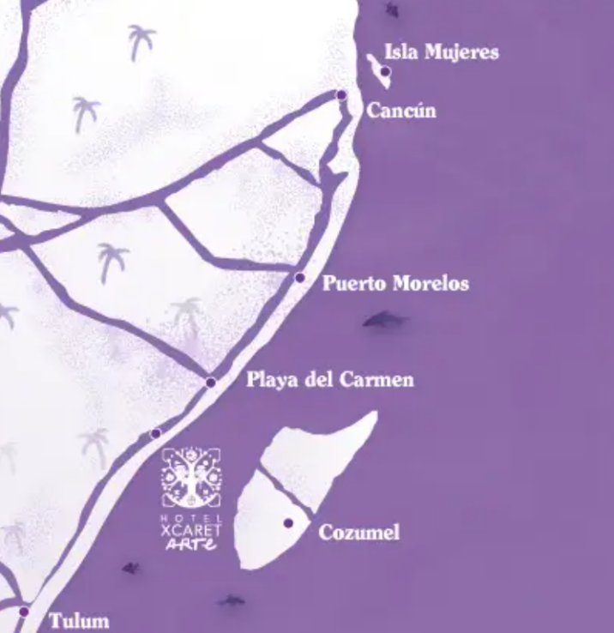
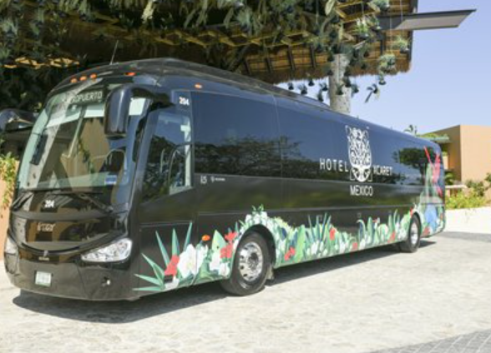

- 45 minutes away from Cancun International Airport
- 45 minutes away from Tulum
- 15 minutes away from Playa del Carmen

  - Guest Rooms - Accommodation

Availability and Rates

The resort has 900 guest rooms distributed in different houses. For this special occasion, we will book the House of the Artist suites. This house represents the most exclusive one of the hotel, as it allows access to its guests to the Kibi-Kibi restaurant, main gym, and swimming pools. It can take in all of our guests as follows:
The group of 495 people will start the journey on different days; the top 25 qualifiers will be allowed one extra day before everyone arrives. For the rest of the travelers, the stay is three nights, four days.
- For the event team (5 people), we will book the ROH Garden Suite.
- For the top qualifiers (25 people + guests), we will reserve the Ocean Front Suite.
- For the two Senior Head Office (2 people + guest), we will book the Presidential Suite. They will arrive one day ahead with the top qualifiers.
- For the rest of the qualifiers (200 + guests), we will reserve the Ocean View Suite.
- For the rest of the Head Office Management (18 + guests), we will also book the Ocean View Suite.

Room Type | May 22  VIP arrival | 645 | May 24  Day 2 | May 25  Day 3 | May 26  Group departure  Day 4 | Rates
Ocean Front – Casa Artistas (exclusive) | 25 | 25 | 25 | 25 | 0 | $ 381
Presidential Suites | 2 | 2 | 2 | 2 | 0 | $ 2286
Ocean View Suite | 0 | 218 | 218 | 218 | 0 | $ 363
Run of the House | 5 | 5 | 5 | 5 | 0 | $ 285

Run of the House – Garden Suite
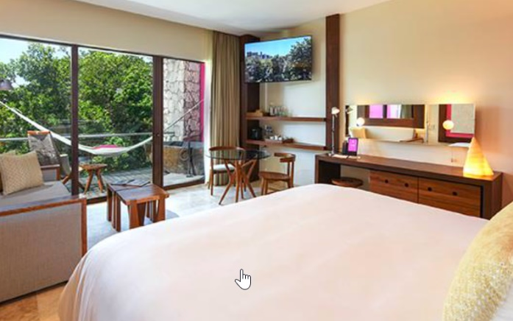
Beds: one King / one Queen
Size: 60 m2 | 645 ft2
View: Garden
Amenities: Premium organic
Extras: Jacuzzi in the room
Individual balcony
All included minibar and snack basket

Ocean View Suite
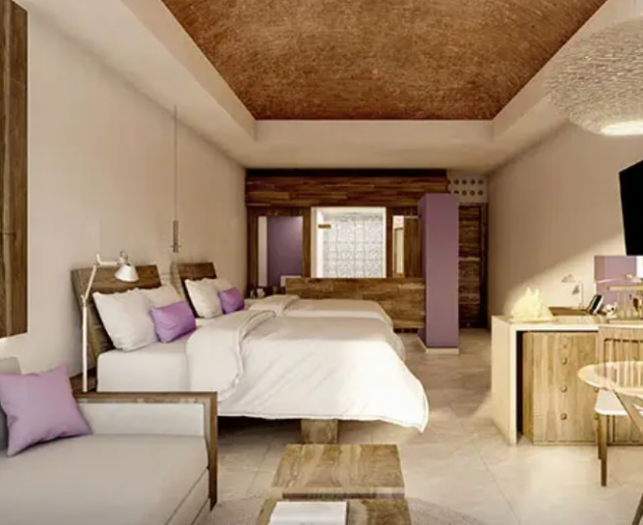
Beds: one King / two double
Size: 60 m2 | 645 ft2
View: Ocean
Amenities: Premium organic
Extras: Jacuzzi in the room
Individual balcony
All included minibar and snack basket

Ocean Front Suite
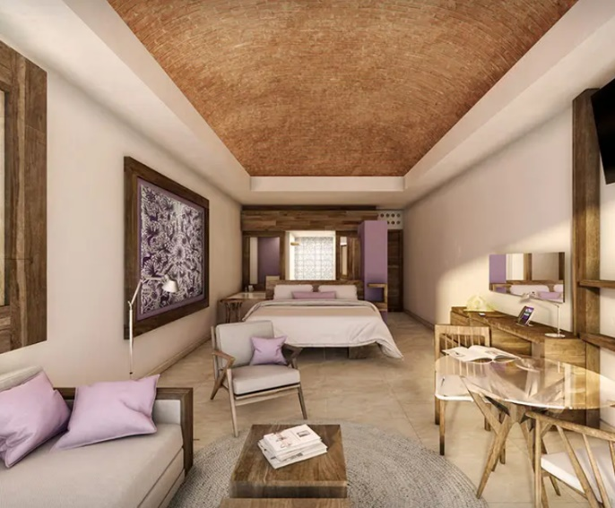
Beds: one King / two double
Size: 60 m2 | 645 ft2
View: Ocean Front
Amenities: Premium organic
Extras: Jacuzzi in the room
Individual balcony
All included minibar and snack basket
Access to the main gym

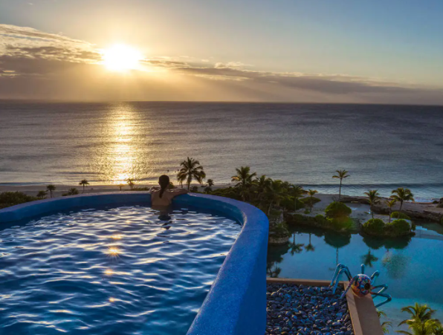
Exclusive swimming pool access from
bedroom's terrace
Early check-in and late check-out
Complete access to Kibi-Kibi restaurant

Presidential Suite

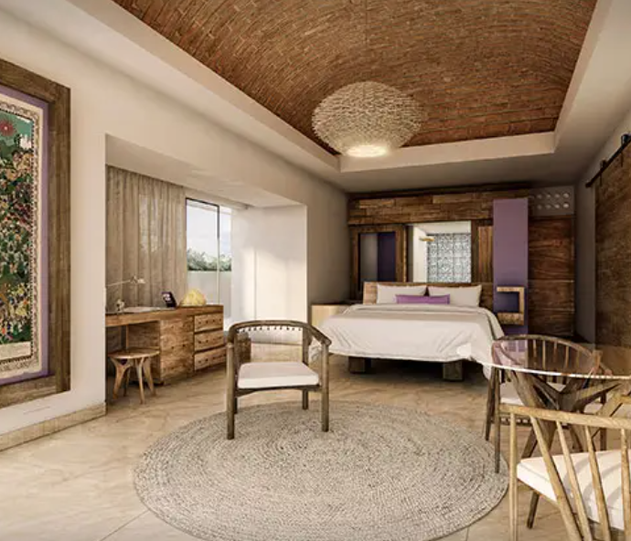
Beds: one King and two double
Size: 430 m2 | 4628 ft2
View: Ocean Front
Amenities: Premium organic
Extras: Jacuzzi in the room
Kitchen area
Dining area for 10
One extra half bathroom
Access to the terrace
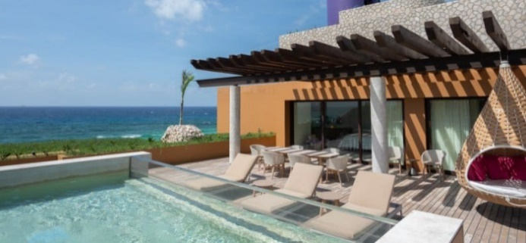
Four balconies
Outside pool
Sunbathing area

Taxes and Fees
- Rates include 3% of accommodation
- Rates include 16% of VAT (subject to governmental changes)
- Wi-fi included
Check-in-out time
- Check-in at 15:00 and check-out at noon

Special Licences for Groups
- One hour of Private Welcoming cocktail with Premium Bar and four canapés per person before 23:00 HRS. (A/V not included)
- Meeting hall with a coffee break. (Coffee, tea, water, assorted sodas, and cookies)
- One courtesy private dinner, including food stations or plating service, open bar, and up to 3 hours of open bar and service before 23:00 HRS. (A/V not included)
- One courtesy suite per every 35 suites paid per night, max 3 per group
- One courtesy upgrade per every 35 suites delivered per night, max 3 per group
- One welcome amenity for VIP group
- 15% off in the Muluk Spa treatments
- Private check-in for the group
- Concierge
Meeting Experience
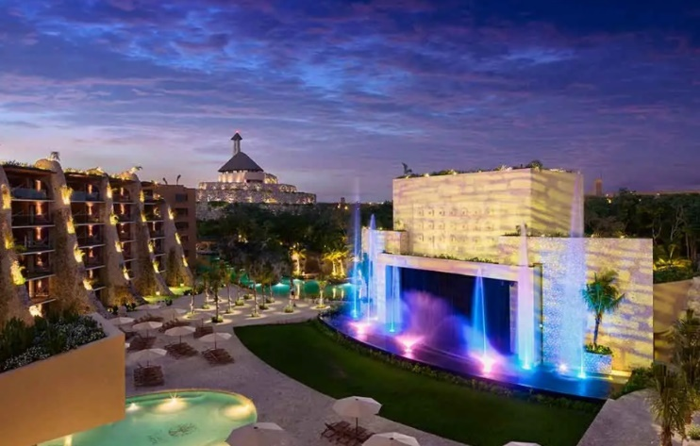
Terraces at Convention Center level

DAY 1 | Time | Event | Room | # of people | Comments
DAY 1 | 12:00 to 18:00 | Conference Registration | Foyer | 500 | One gift per person, light snacks.
DAY 1 | 18:30 to 19:30 | Welcome Reception | Terraces at Convention Center Level | 500 | 1 hour.  We will use the special license given by the hotel, with Premium Bar and four canapés per person.
DAY 1 | 20:00 to 22:30 | Dinner | Diego II and III | 500 | Banquet style

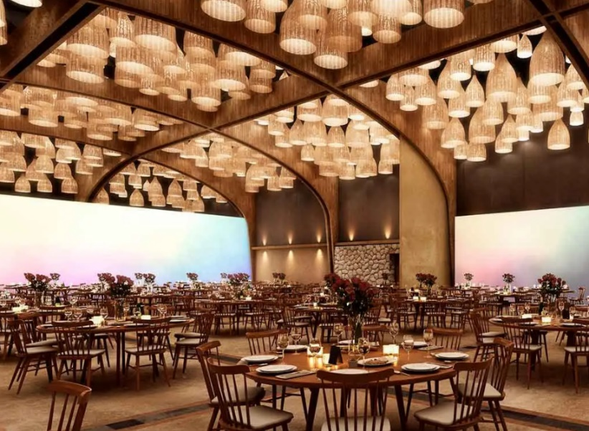
Diego II and Diego III
Height: 26 ft
Length: 79 ft
Width: 71 ft
SQFT2: 5,640
Banquet: 250

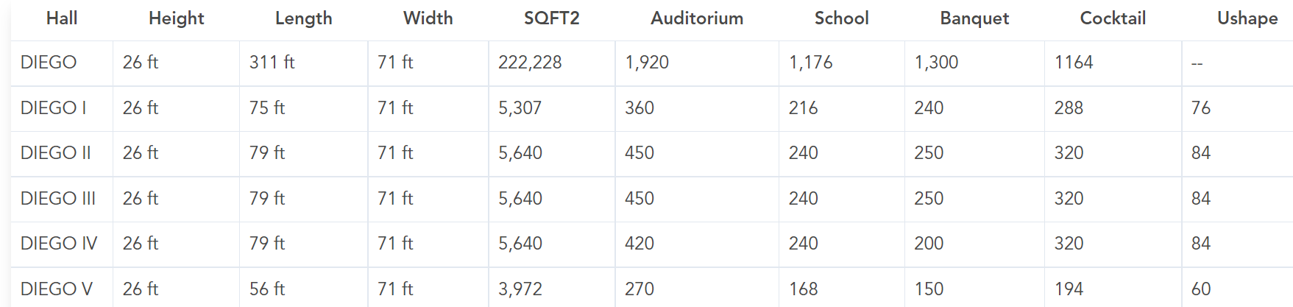

DAY 2 | Time | Event | Room | # of people | Comments
DAY 2 | 08:30 to 10:00 | Qualifiers breakfast | Mercado de San Juan | 250 | Restaurant with a festive atmosphere of a typical Mexican market.
DAY 2 | 10:30 to 12:30 | Education session | Diego I | 250 | Qualifiers + Head Office.  Formal welcome.  Marketing and sales presentation.  Input on the new product. Round table style.
DAY 2 | 12:30 to 13:00 | Coffee break | Terraces at Convention Center Level | 250 | We will use the special license from the hotel: Coffee, tea, water, assorted sodas, and cookies.
DAY 2 | 13:30 | Lunch | Box lunches | 500 | Items delivered to each room.
DAY 2 | Starting at 19:30 | Dinner | Nine different restaurants | 500 | Guests will pre-register for a restaurant or select "on their own."

For Dinner on Day 2, the guests will have to pre-register with 30 days of anticipation, especially for the most popular ones, which are Kibi-Kibi and Encanta. The first one is trendy because it is an exclusive restaurant only available for guests at the House of Artists. On the other hand, Encanta's popularity is due to its Michelin Star chef.

DAY 3 | Time | Event | Room | # of people | Comments
DAY 3 | 07:00 to 08:30 | Breakfast | Arenal or Xaak restaurants | 500 | Both restaurants offer buffet-style breakfast.
DAY 3 | 09:00 to 12:00 | Motivational Conference and Wrap-up | Frida I | 250 | Auditorium style.  Food and beverages available.
DAY 3 | 12:30 to 14:30 | Lunch | Terraces at Convention Center level | 500 | Buffet-style
DAY 3 | 20:00 | Reception and Gala Night | Foyer.  Diego II and Diego III | 500 | The reception will take place in the Foyer. The dinner at Diego Convention Center, round tables.

The Gala Night will start with a reception at the Foyer where guests will enjoy a warm musical, with excellent performers and assorted instruments, from the violin and psaltery, to mariachis, string duets, puppets, and more; while waiting to enter the Diego Convention Center.
For the Gala Night, we will use Diego II and Diego III to host the 500 guests. The space will be set up banquet-style with round tables of 10.
The hotel provided a group sample menu of 8 courses made with local ingredients. A vegetarian or vegan menu is available upon request.

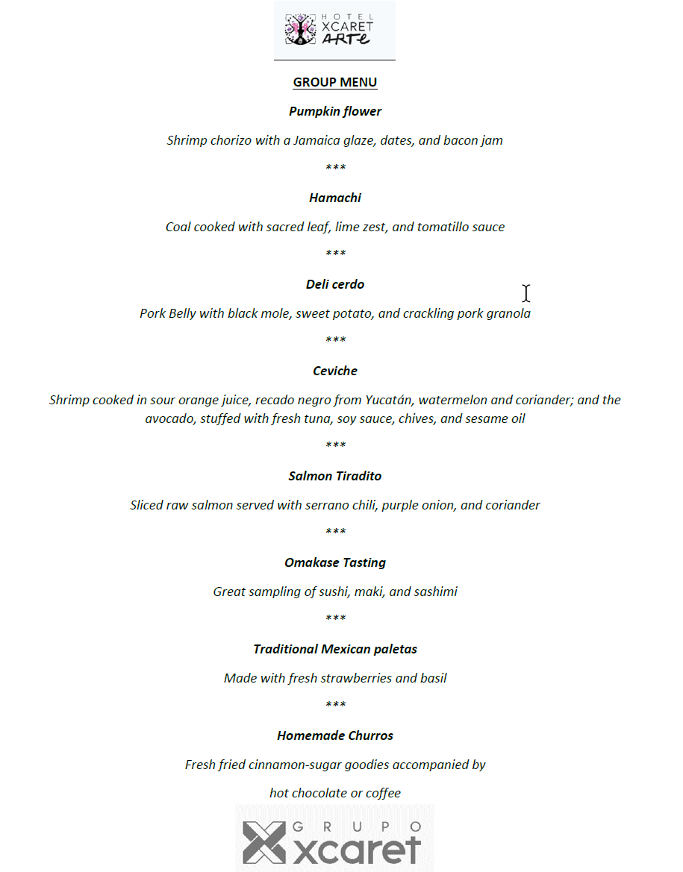
DAY 4 | Time | Event | Room | # of people | Comments
DAY 4 | Each guest will decide time according to departure time | Breakfast | Room service | 500 | The hotel offers in room dinning service 24 hours without additional charge.
DAY 4 | 07:30 to 16:40 | Departures |  | 500 | Pre-arrenged transportation to the airport, hotel cortesy.
DAY 4 | 12:00 | Team debrief meeting |  |  | Teardown of meeting space.

References

Hotel Xcarte Arte. (2021). About Us. Grupo Xcaret. https://www.hotelxcaretarte.com/en/about-hotel-xcaret-arte/
Tellez, A. (2021). Conestoga-HXAR. [Group quotation]. Retrieved on September 23, 2021, from email
Tellez, A. (2021). Xcaret Group Parks Experience. [Group quotation]. Retrieved on September 23, 2021, from email
Tellez, A. (2021). Sample group menu. [Group quotation]. Retrieved on September 23, 2021, from email

